[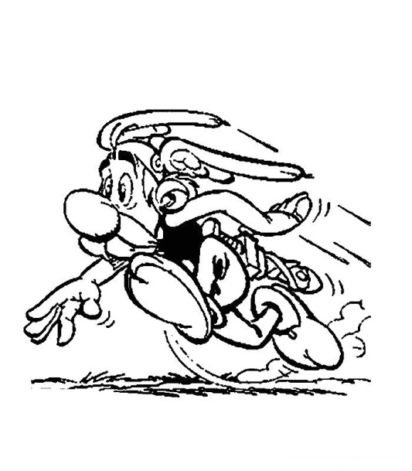](http://www.google.ca/url?sa=i&rct=j&q=&esrc=s&source=images&cd=&cad=rja&uact=8&ved=0ahUKEwjdtrCbmcfRAhUKxYMKHTN4CVwQjRwIBw&url=http%3A%2F%2Fazcoloriage.com%2Fdessin-de-asterix-et-obelix&psig=AFQjCNE3l2qNY0hrrG6msKrUtPDdcArEvA&ust=1484674184130895)[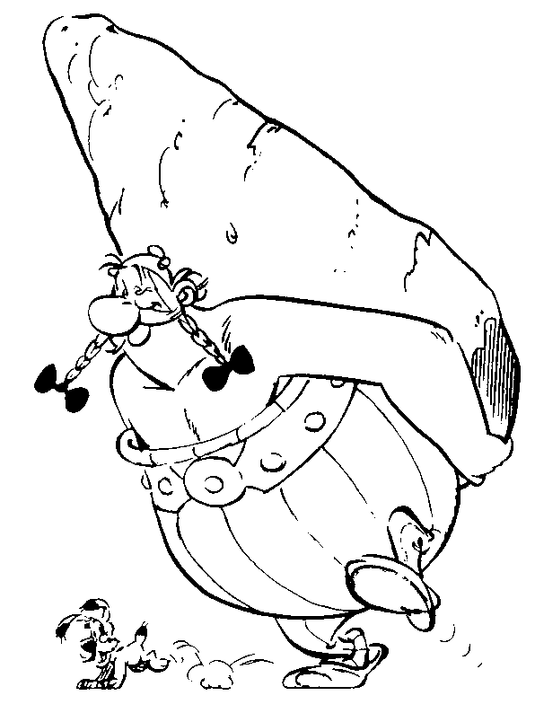](https://www.google.ca/url?sa=i&rct=j&q=&esrc=s&source=images&cd=&cad=rja&uact=8&ved=0ahUKEwjVq7fdmMfRAhXr44MKHZQkANgQjRwIBw&url=https%3A%2F%2Fwww.buzz2000.com%2Fcoloriage-asterix.html&psig=AFQjCNE3l2qNY0hrrG6msKrUtPDdcArEvA&ust=1484674184130895)

**Astérix et Obélix**

[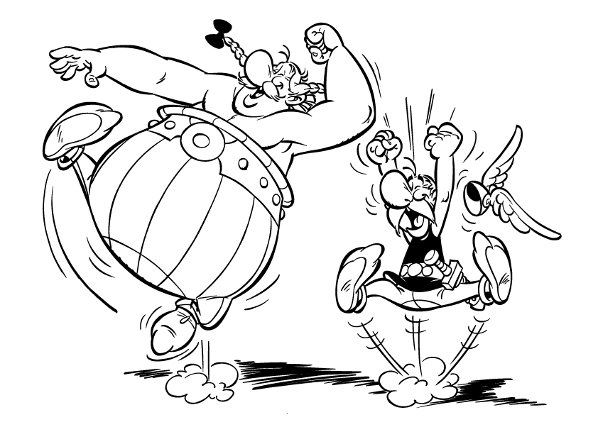](http://www.google.ca/url?sa=i&rct=j&q=&esrc=s&source=images&cd=&cad=rja&uact=8&ved=0ahUKEwjp3t28mMfRAhXH54MKHUL7D5YQjRwIBw&url=http%3A%2F%2Fwww.snut.fr%2Fdessin-de-asterix-et-obelix%2F&psig=AFQjCNE3l2qNY0hrrG6msKrUtPDdcArEvA&ust=1484674184130895)[](http://www.topkool.com/fr/bandes-dessinees/asterix-le-gaulois)[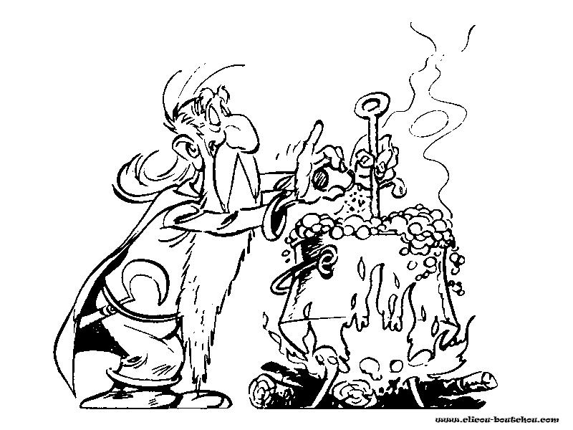](https://www.google.ca/url?sa=i&rct=j&q=&esrc=s&source=images&cd=&cad=rja&uact=8&ved=0ahUKEwiwn8G_mcfRAhUKwYMKHVTeCVkQjRwIBw&url=https%3A%2F%2Fcoloriagesaimprimer.com%2Fcoloriages%2Fdessins-animes%2Fasterix-et-obelix%2F24%2F&psig=AFQjCNE3l2qNY0hrrG6msKrUtPDdcArEvA&ust=1484674184130895)

**Prénom: ___________**

Carnet du lecteur